**(Relational Database Service) RDS 101**

**What is a relational database?**

* Relational databases are what most of us are all used to. They have been around since the 70s. Think of a traditional spreadsheet.
  + Database
  + Tables
  + Row
  + Fields (Columns)

**Relational Databases example:**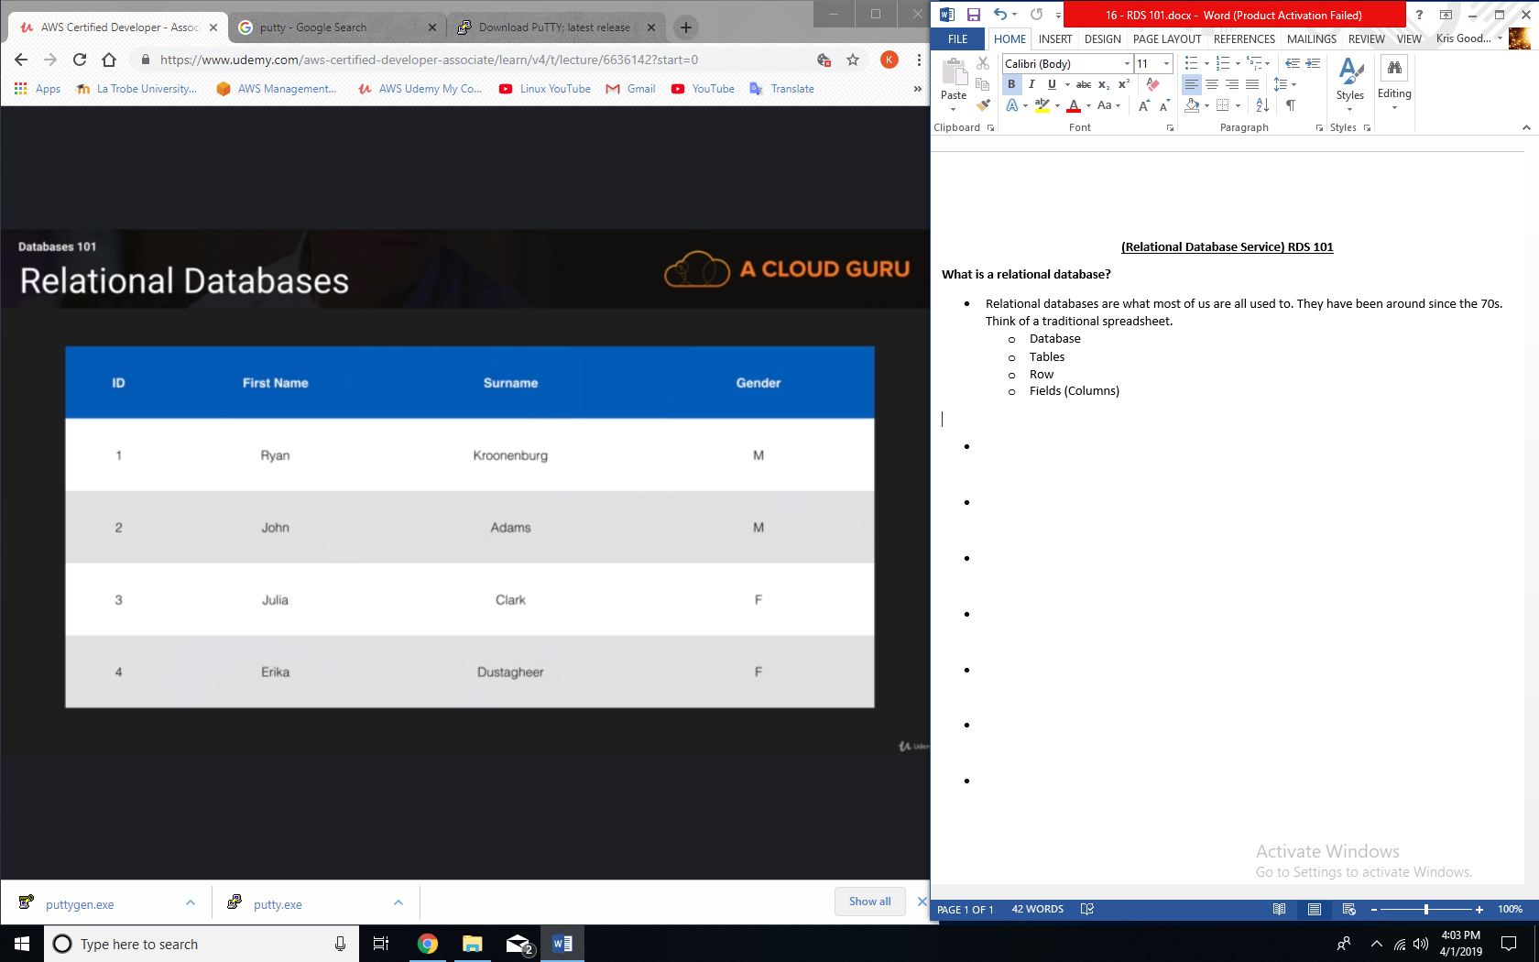

**Relational Database Types:**

* SQL Server
* Oracle
* MySQL Server
* PostgreSQL
* Aurora
* MariaDB

**Non-relational databases:**

* Database
  + Collection = Table
  + Document = Row
  + Key Value Pairs = Fields

**JSON/NoSQL:**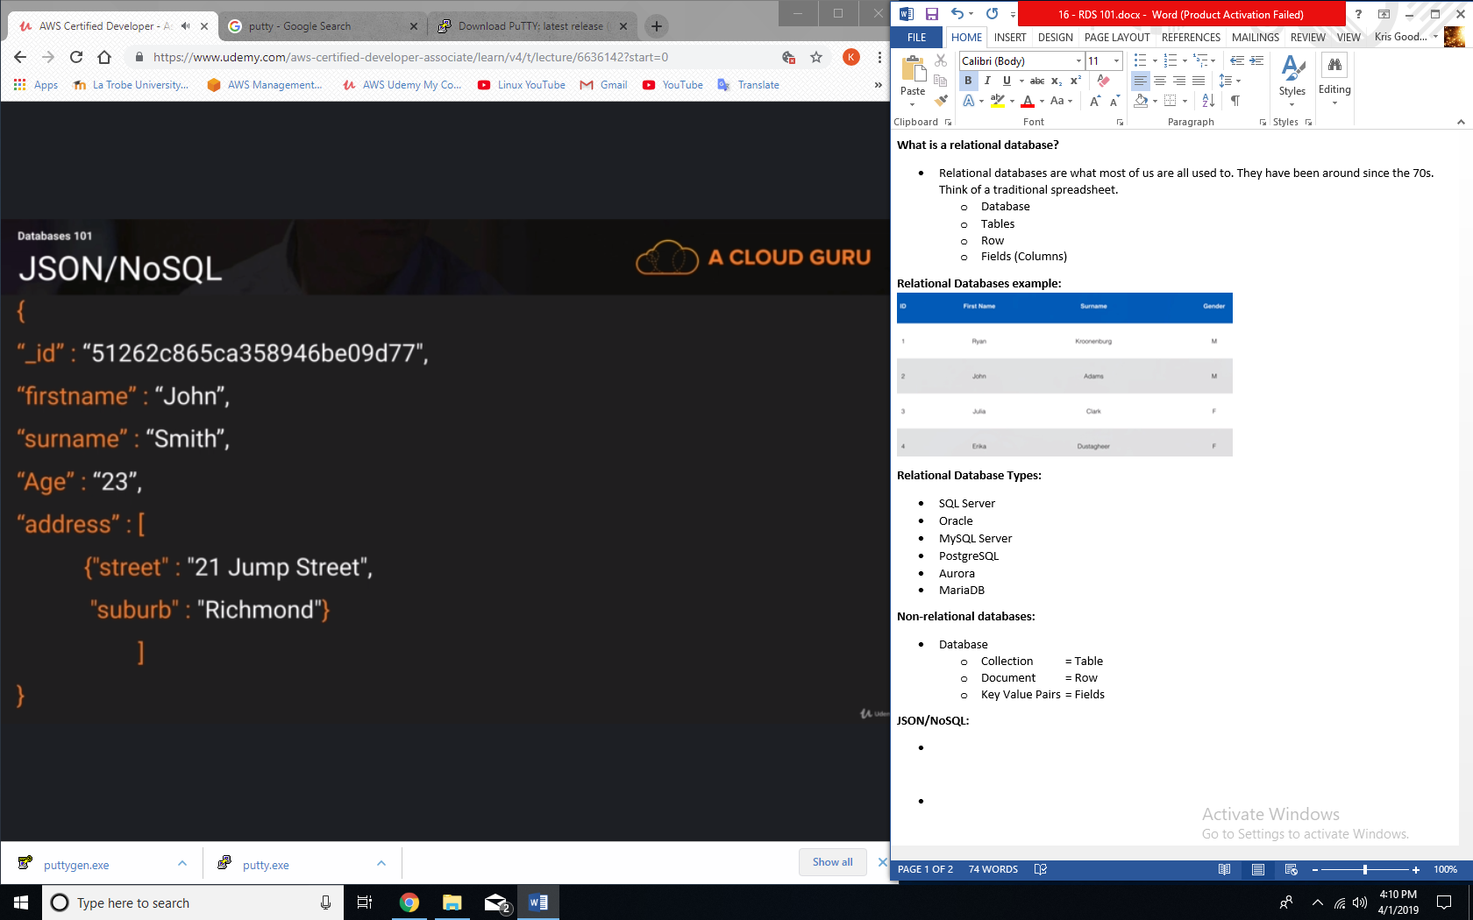

**What is data warehousing?**

* Used for business intelligence. Tools like Cognos, Jaspersoft, SQL Server Reporting Services, Oracle Hyperion, and SAP NetWeaver.
* Used to pull in very large and complex data sets. Usually used by management to do queries on data (such as current performance vs targets, etc.)

**OLTP vs OLAP:**

* Online Transaction Processing (OLTP) differs from Online Analytics Processing (OLAP) in terms of the types of queries you will run.
* OLTP Example:
  + Order number 2120121
  + Pulls up a row of data such as Name, Date, Address to deliver to, Delivery Status, etc.
* OLAP transaction Example:
  + Net profit for EMEA and Pacific for the digital radio product.
  + Pulls in large numbers of records.
  + Sum of radios sold in EMEA
  + Sum of radios sold in Pacific